BookFlow Library Management System – Week 1
Name: Sohith
Roll No: 25200300389
Course: Database System Engineering and Distributed Backend Development
Task 1: MySQL Login
C:\Program Files\MySQL\MySQL Server 8.0\bin>mysql -u root -p
Enter password: ****
Welcome to the MySQL monitor. Commands end with ; or \g.
Your MySQL connection id is 15
Server version: 8.0.46 MySQL Community Server - GPL

Copyright (c) 2000, 2026, Oracle and/or its affiliates.

Oracle is a registered trademark of Oracle Corporation and/or its
affiliates. Other names may be trademarks of their respective
owners.

Type 'help;' or '\h' for help. Type '\c' to clear the current input statement.
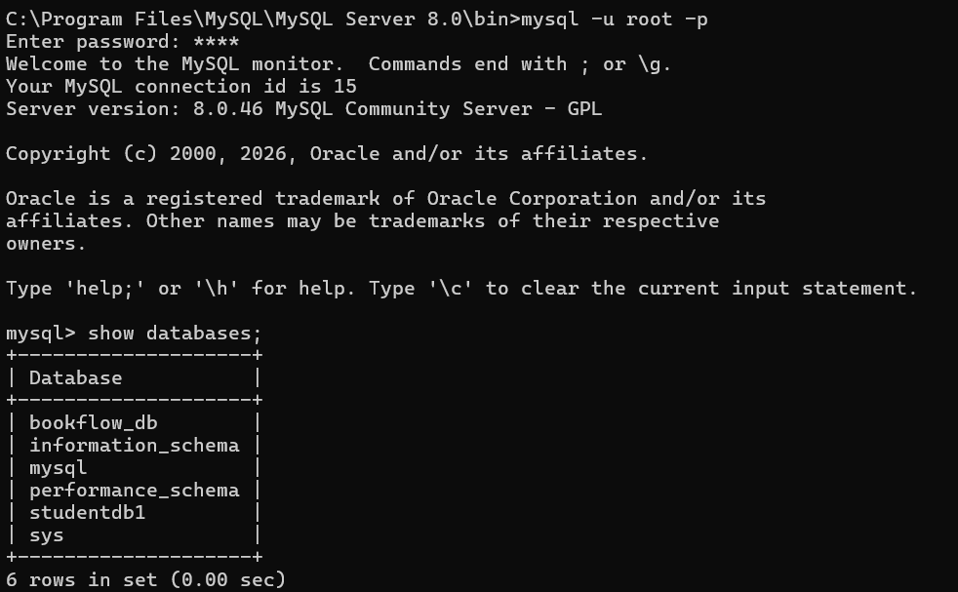
Task 2: Database Creation
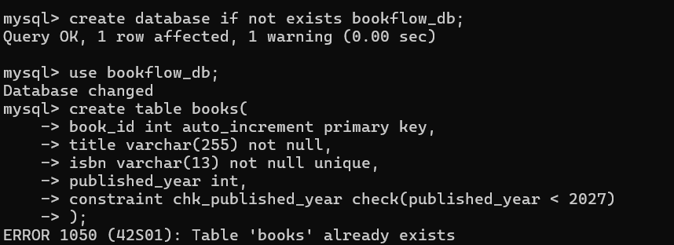
Task 3: Books Table Creation
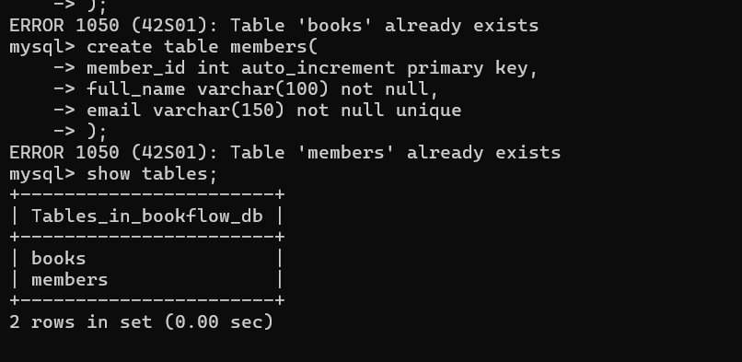
Task 4: Members Table Creation
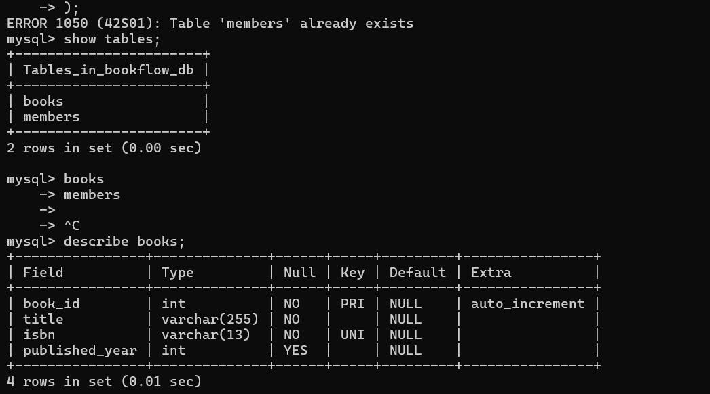
Task 5: Insert Sample Data
